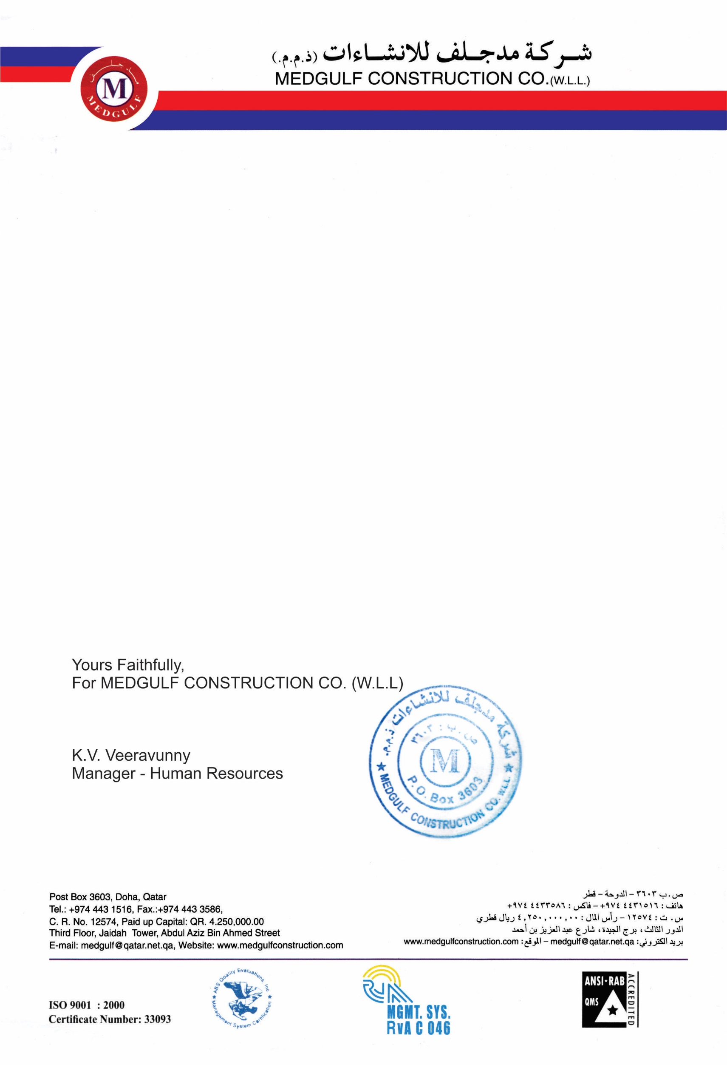

Ref : HR/12096/TER

Date : <To2>

**EXPERIENCE CERTIFICATE**

PROJECT : MEDGULF CONSTRUCTION

TERM : <From2> To <To2>

NAME : <Name>

TRADE : <Designation>

It was confirmed that this guy has worked properly for completion of the MED GULF CONSTRUCTION.

